已知立方和不等式为 1³+ 2³+…+ m³< n 对指定的n值，试求满足上述立方和不等式的m的整数解。
输入提示
同构数
625的右端，25就是同构

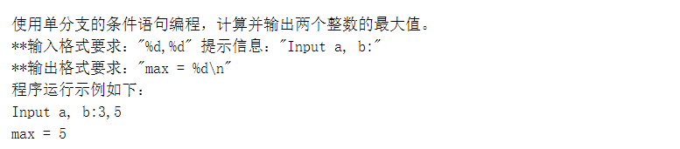
#include<stdio.h>
int main()
{
int a,b,max;
printf("Input a, b:");
scanf("%d,%d",&a,&b);
max = (a>b)?a:b;
printf("max = %d\n",max);
return 0;
}

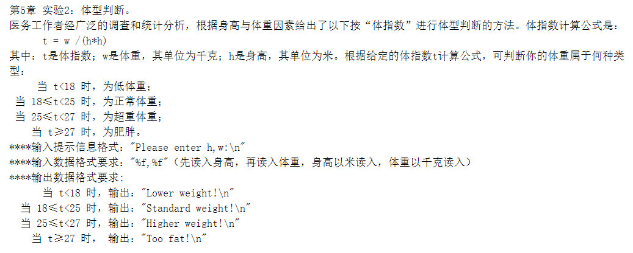
#include<stdio.h>
int main()
{
float h,w,t;
printf("Please enter h,w:\n");
scanf("%f,%f",&h,&w);
t = w/(h*h);
if(t<18)
{
printf("Lower weight!\n");
}
else if(t>=18&&t<25)
{
printf("Standard weight!\n");
}
else if(t>=25&&t<27)
{
printf("Higher weight!\n");
}
else
{
printf("Too fat!\n");
}
return 0;
}

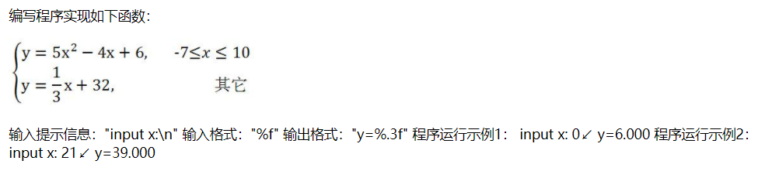
#include<stdio.h>
#include<math.h>
int main()
{
float x,y;
printf("input x:\n");
scanf("%f",&x);
if(x>=(-7)&&x<=10)
{
y = 5*pow(x,2)-4*x+6;
printf("y=%.3f",y);
}
else
{
y = x/3+32;
printf("y=%.3f",y);
}
return 0;
}

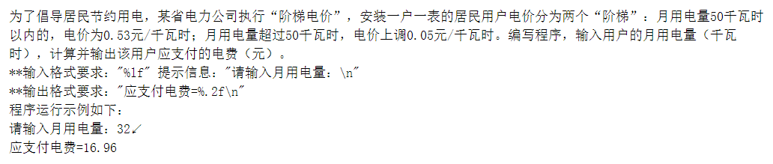

#include<stdio.h>
int main()
{
double a,b;
printf("请输入月用电量：\n");
scanf("%lf",&a);
if(a>=0&&a<=50)
{
b = 0.53*a;
printf("应支付电费=%.2f\n",b);
}
else
{
b = (0.53+0.05)*a;
printf("应支付电费=%.2f\n",b);
}
return 0;
}

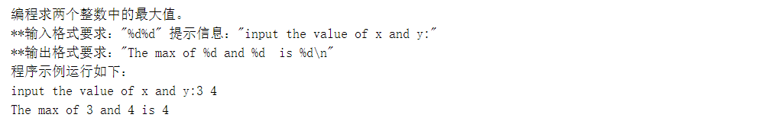

#include<stdio.h>
int main()
{
int x,y,max;
printf("input the value of x and y:");
scanf("%d%d",&x,&y);
max = (x>y)?x:y;
printf("The max of %d and %d is %d\n",x,y,max);
return 0;
}

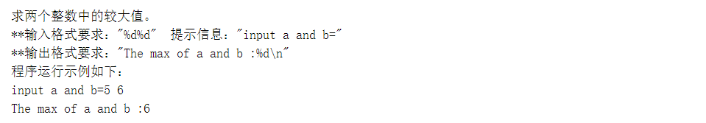

#include<stdio.h>
int main()
{
int a,b,max;
printf("input a and b=");
scanf("%d%d",&a,&b);
max = (a>b)?a:b;
printf("The max of a and b :%d\n",max);
return 0;
}

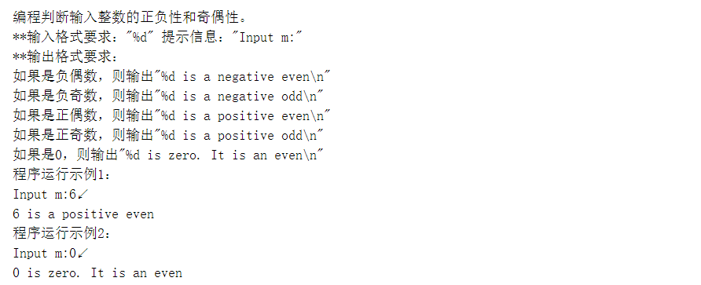

#include<stdio.h>
int main()
{
int a,b;
printf("Input m:");
scanf("%d",&a);
if(a==0)
{
printf("%d is zero. It is an even\n",a);
}
else if(a>0)
{
b = a%2;
if(b==0)
{
printf("%d is a positive even\n",a);
}
else
{
printf("%d is a positive odd\n",a);
}
}
else
{
b = a%2;
if(b==0)
{
printf("%d is a negative even\n",a);
}
else
{
printf("%d is a negative odd\n",a);
}
}
return 0;
}

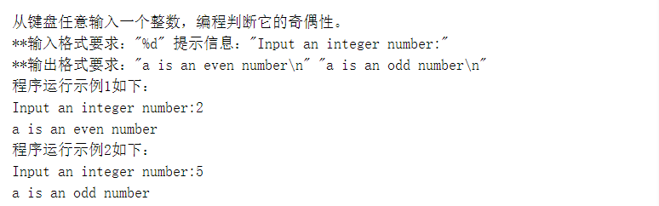

#include<stdio.h>
int main()
{
int a,b;
printf("Input an integer number:");
scanf("%d",&a);
b = a%2;
if(b==0)
{
printf("a is an even number\n");
}
else
{
printf("a is an odd number\n");
}
return 0;
}

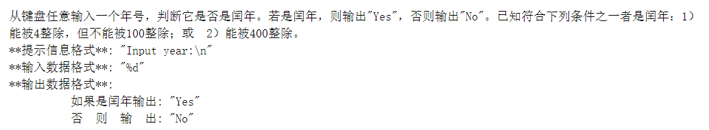

#include<stdio.h>
int main()
{
int a,b,c,d;
printf("Input year:\n");
scanf("%d",&a);
b = a%4;
c = a%100;
d = a%400;
if((b==0&&c>0)||d==0)
{
printf("Yes");
}
else
{
printf("No");
}
return 0;
}

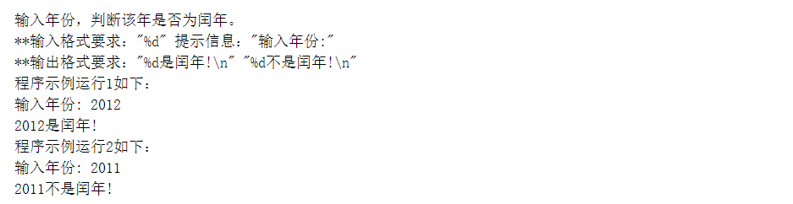

#include<stdio.h>
int main()
{
int a,b,c,d;
printf("输入年份:");
scanf("%d",&a);
b = a%4;
c = a%100;
d = a%400;
if((b==0&&c>0)||d==0)
{
printf("%d是闰年!\n",a);
}
else
{
printf("%d不是闰年!\n",a);
}
return 0;
}

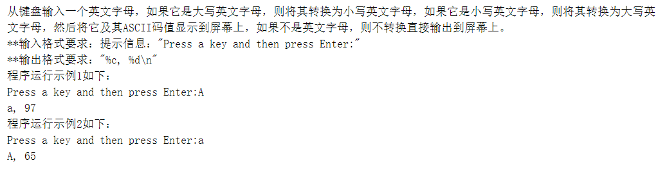

#include<stdio.h>
int main()
{
char ch;
printf("Press a key and then press Enter:");
ch = getchar();
if(ch>='A'&&ch<='Z')
{
ch = ch + 32;
printf("%c, %d\n",ch,ch);
}
else if(ch>='a'&&ch<='z')
{
ch = ch - 32;
printf("%c, %d\n",ch,ch);
}
return 0;
}

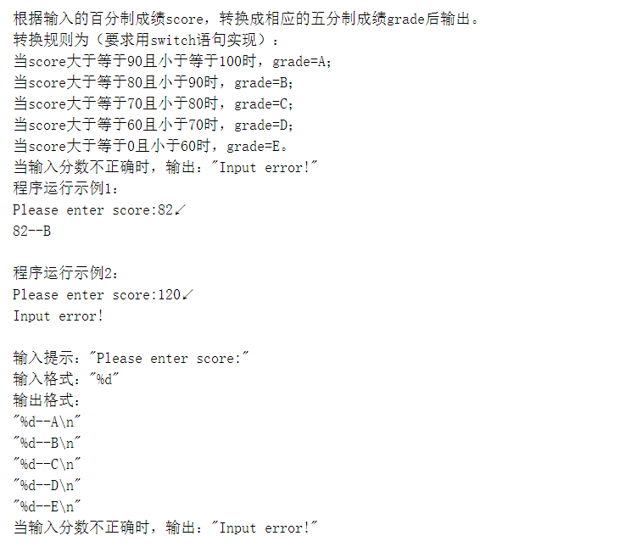

#include<stdio.h>
int main()
{
int score;
printf("Please enter score:");
scanf("%d",&score);
if(score>=90&&score<=100)
{
printf("%d--A\n",score);
}
else if(score>=80&&score<90)
{
printf("%d--B\n",score);
}
else if(score>=70&&score<80)
{
printf("%d--C\n",score);
}
else if(score>=60&&score<70)
{
printf("%d--D\n",score);
}
else if(score>=0&&score<60)
{
printf("%d--E\n",score);
}
else
{
printf("Input error!");
}
return 0;
}

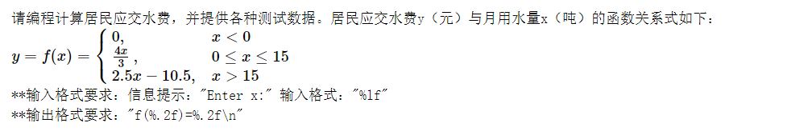

#include<stdio.h>
int main()
{
double x,y;
printf("Enter x:");
scanf("%lf",&x);
if(x<0)
{
y = 0;
printf("f(%.2f)=%.2f\n",x,y);
}
else if(x>=0&&x<=15)
{
y = (4*x)/3;
printf("f(%.2f)=%.2f\n",x,y);
}
else if(x>15)
{
y = 2.5*x-10.5;
printf("f(%.2f)=%.2f\n",x,y);
}
return 0;
}

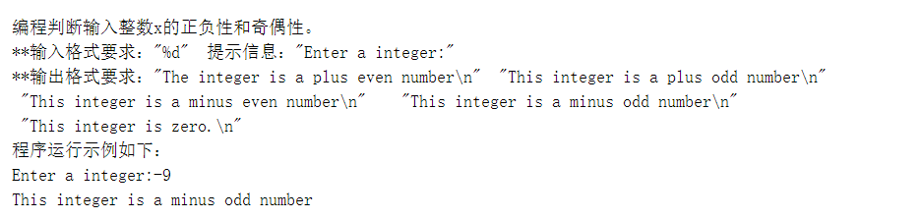
#include<stdio.h>
int main()
{
int a,b;
printf("Enter a integer:");
scanf("%d",&a);
b = a%2;
if(a==0)
{
printf("This integer is zero.\n");
}
else if(a>0)
{
if(b==0)
{
printf("The integer is a plus even number\n");
}
else printf("This integer is a plus odd number\n");
}
else
{
if(b==0)
{
printf("This integer is a minus even number\n");
}
else printf("This integer is a minus odd number\n");
}
return 0;
}

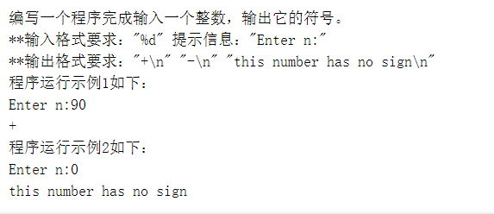

#include<stdio.h>
int main()
{
int n;
printf("Enter n:");
scanf("%d",&n);
if(n==0)
{
printf("this number has no sign\n");
}
else if(n>0)
{
printf("+\n");
}
else if(n<0)
{
printf("-\n");
}
return 0;
}

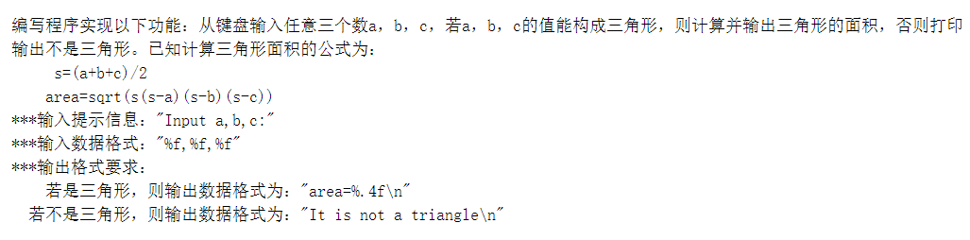

#include<stdio.h>
#include<math.h>
int main()
{
float a,b,c,s,area;
printf("Input a,b,c:");
scanf("%f,%f,%f",&a,&b,&c);
s = (a+b+c)/2;
area = sqrt(s*(s-a)*(s-b)*(s-c));
if((a+b>c)&&(a+c>b)&&(b+c>a))
{
printf("area=%.4f\n",area);
}
else
{
printf("It is not a triangle\n");
}
return 0;
}

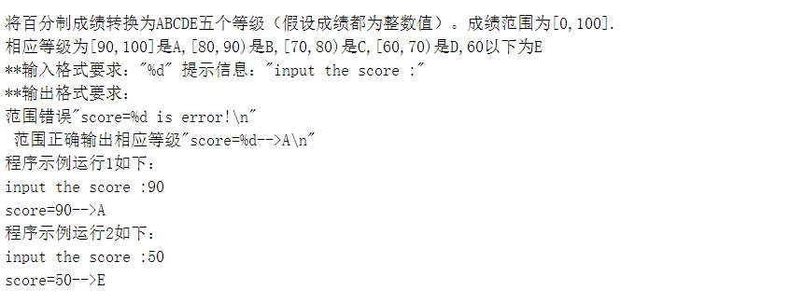

#include<stdio.h>
void main()
{
int a;
printf("input the score :");
scanf("%d",&a);
if (a>100||a<0) printf("score=%d is error!\n",a);
else if (a>=90) printf("score=%d-->A\n",a);
else if (a>=80) printf("score=%d-->B\n",a);
else if (a>=70) printf("score=%d-->C\n",a);
else if (a>=60) printf("score=%d-->D\n",a);
else printf("score=%d-->E\n",a);
return 0;
}

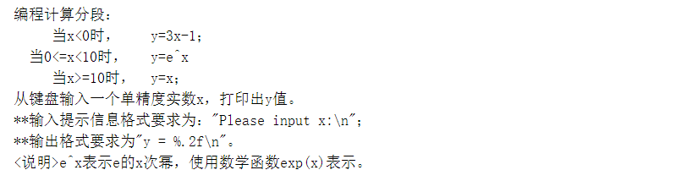

#include<stdio.h>
#include<math.h>
int main()
{
float x,y;
printf("Please input x:\n");
scanf("%f",&x);
if(x<0)
{
y = 3*x-1;
}
else if(x>=10)
{
y = x;
}
else
{
y = exp(x);
}
printf("y = %.2f\n",y);
return 0;
}

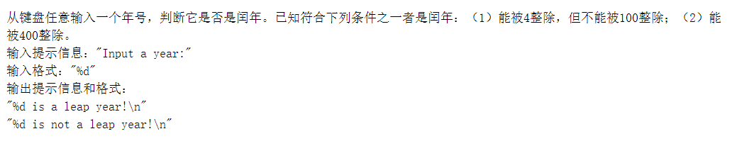

#include<stdio.h>
int main()
{
int a,b,c,d;
printf("Input a year:");
scanf("%d",&a);
b = a%4;
c = a%100;
d = a%400;
if((b==0&&c>0)||d==0)
{
printf("%d is a leap year!\n",a);
}
else printf("%d is not a leap year!\n",a);
return 0;
}

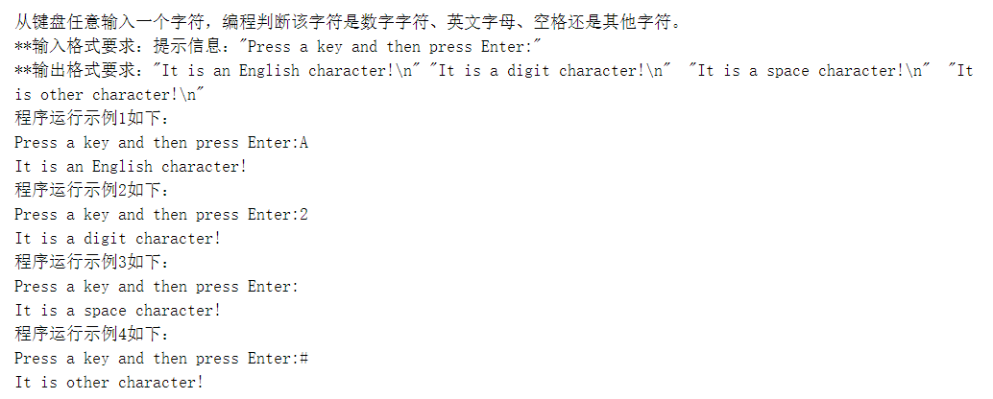

#include<stdio.h>
int main()
{
char a;
printf("Press a key and then press Enter:");
scanf("%c",&a);
if (a>64 && a<91||a>96 && a<123) printf("It is an English character!\n");
else if (a>47 && a<58) printf("It is a digit character!\n");
else if (a==32) printf("It is a space character!\n");
else printf("It is other character!\n");
return 0;
}

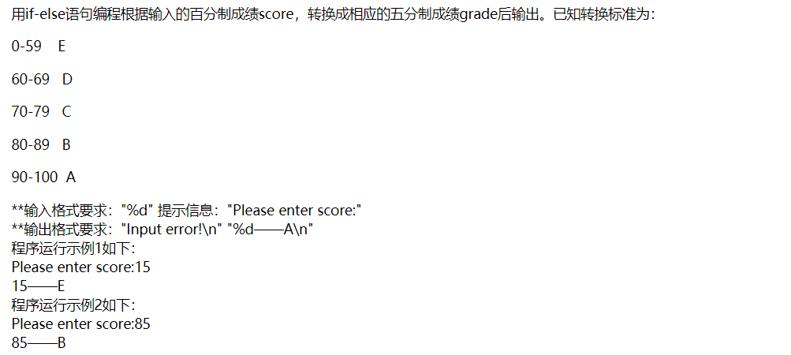
#include<stdio.h>
int main()
{
int a;
printf("Please enter score:");
scanf("%d",&a);
if(a>=0&&a<=59)
{
printf("%d——E\n",a);
}
else if(a>=60&&a<=69)
{
printf("%d——D\n",a);
}
else if(a>=70&&a<=79)
{
printf("%d——C\n",a);
}
else if(a>=80&&a<=89)
{
printf("%d——B\n",a);
}
else if(a>=90&&a<=100)
{
printf("%d——A\n",a);
}
else printf("Input error!\n");
return 0;
}

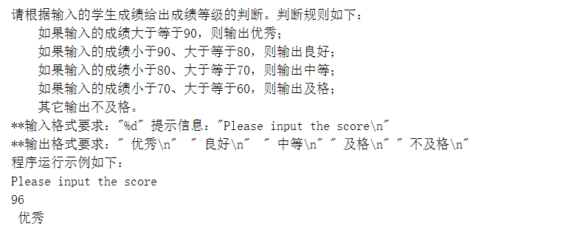

#include<stdio.h>
int main()
{
int a;
printf("Please input the score\n");
scanf("%d",&a);
if(a>=90)
{
printf(" 优秀\n");
}
else if(a>=80&&a<90)
{
printf(" 良好\n");
}
else if(a>=70&&a<80)
{
printf(" 中等\n");
}
else if(a>=60&&a<70)
{
printf(" 及格\n");
}
else
{
printf(" 不及格\n");
}
}

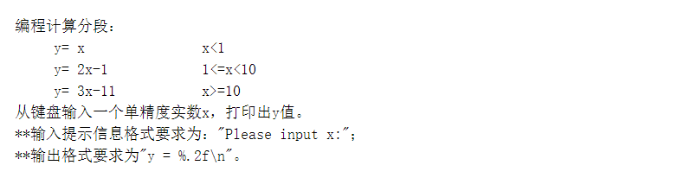

#include<stdio.h>
int main()
{
float x,y;
printf("Please input x:");
scanf("%f",&x);
if(x<1)
{
y = x;
}
else if(x>=10)
{
y = 3*x-11;
}
else
{
y = 2*x-1;
}
printf("y = %.2f\n",y);
return 0;
}

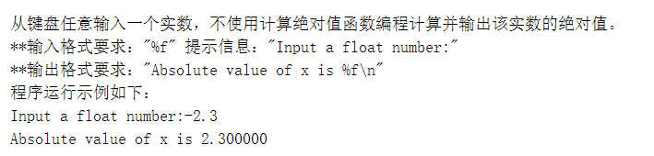

#include<stdio.h>
int main()
{
float n;
printf("Input a float number:");
scanf("%f",&n);
if(n<0)
{
printf("Absolute value of x is %f\n",(-n));
}
else
{
printf("Absolute value of x is %f\n",n);
}
return 0;
}

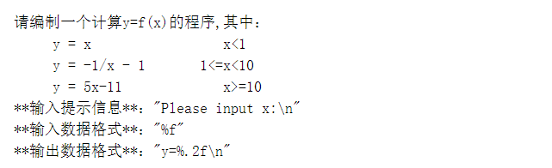

#include<stdio.h>
int main()
{
float x,y;
printf("Please input x:\n");
scanf("%f",&x);
if(x<1)
{
y = x;
}
else if(x>=10)
{
y = 5*x - 11;
}
else
{
y = -1/x - 1;
}
printf("y=%.2f\n",y);
return 0;
}

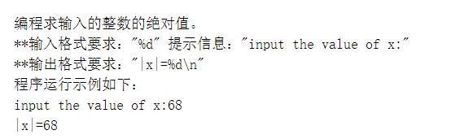

#include<stdio.h>
#include<math.h>
int main()
{
int n,m;
printf("input the value of x:");
scanf("%d",&n);
m = fabs(n);
printf("|x|=%d\n",m);
return 0;
}

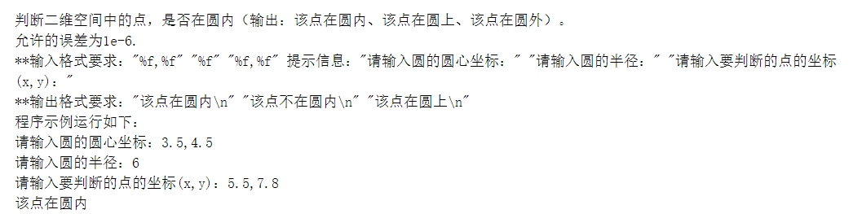

#include <stdio.h>
#include <math.h>
int main()
{
float a,b,r,x,y;
double m,n;
printf("请输入圆的圆心坐标：");
scanf("%f,%f",&a,&b);
printf("请输入圆的半径：");
scanf("%f",&r);
printf("请输入要判断的点的坐标(x,y)：");
scanf("%f,%f",&x,&y);
m=pow(x-a,2);
n=pow(y-b,2);
if (m+n<r*r)
printf("该点在圆内\n");
else if (m+n>r*r)
printf("该点不在圆内\n");
else if (m+n==r*r)
printf("该点在圆上\n");
return 0;
}

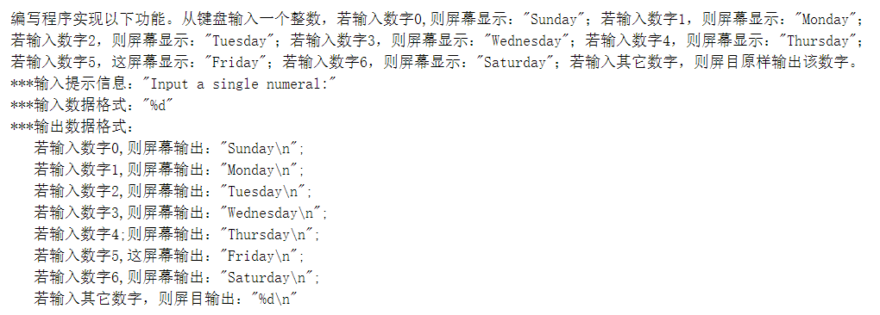

#include<stdio.h>
int main()
{
int n;
printf("Input a single numeral:");
scanf("%d",&n);
if(n==0)
printf("Sunday\n");
else if(n==1)
printf("Monday\n");
else if(n==2)
printf("Tuesday\n");
else if(n==3)
printf("Wednesday\n");
else if(n==4)
printf("Thursday\n");
else if(n==5)
printf("Friday\n");
else if(n==6)
printf("Saturday\n");
else printf("%d\n",n);
return 0;
}

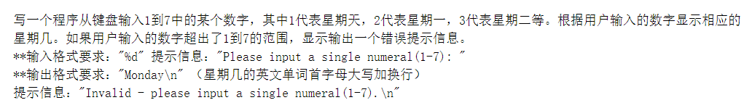

#include<stdio.h>
int main()
{
int n;
printf("Please input a single numeral(1-7): ");
scanf("%d",&n);
if(n==1)
printf("Sunday\n");
else if(n==2)
printf("Monday\n");
else if(n==3)
printf("Tuesday\n");
else if(n==4)
printf("Wednesday\n");
else if(n==5)
printf("Thursday\n");
else if(n==6)
printf("Friday\n");
else if(n==7)
printf("Saturday\n");
else printf("Invalid - please input a single numeral(1-7).\n");
return 0;
}
用if-else语句编程根据输入的百分制成绩score，转换成相应的五分制成绩grade后输出。已知转换标准为：

0-59 E

60-69 D

70-79 C

80-89 B

90-100 A

**输入格式要求："%d" 提示信息："Please enter score:"
**输出格式要求："Input error!\n" "%d——A\n"
程序运行示例1如下：
Please enter score:15
15——E
程序运行示例2如下：
Please enter score:85
85——B

#include<stdio.h>
main()
{
int score, mark;
printf("Please enter score:");
scanf("%d" , &score);
if (score < 0 || score > 100)
{
mark = -1;
}
else
{
mark = score / 10;
}
switch (mark)
{
case 10:
case 9:
printf("%d——A\n", score);
break;
case 8:
printf("%d——B\n", score);
break;
case 7:
printf("%d——C\n", score);
break;
case 6:
printf("%d——D\n", score);
break;
case 5:
case 4:
case 3:
case 2:
case 1:
case 0:
printf("%d——E\n", score);
break;
default:
printf("Input error!\n");
}
}
请编程计算居民应交水费，并提供各种测试数据。居民应交水费y（元）与月用水量x（吨）的函数关系式如下：
y=f(x)=⎧⎩⎨0,4x3,2.5x−10.5,x<00≤x≤15x>15
**输入格式要求：信息提示："Enter x:" 输入格式："%lf"
**输出格式要求："f(%.2f)=%.2f\n"
#include<stdio.h>
int main(void)
{
double x, y;
printf("Enter x:");
scanf("%lf", &x);
if (x < 0)
{
y = 0;
printf("f(%.2f)=%.2f\n", x, y);
}
else if (x >= 0 && x <= 15)
{
y = 4 * x / 3.0;
printf("f(%.2f)=%.2f\n", x, y);
}
else
{
y = 2.5 * x - 10.5;
printf("f(%.2f)=%.2f\n", x, y);
}
}
编程计算分段：
y= x x<1
y= 2x-1 1<=x<10
y= 3x-11 x>=10
从键盘输入一个单精度实数x，打印出y值。
**输入提示信息格式要求为："Please input x:"；
**输出格式要求为"y = %.2f\n"。
#include<stdio.h>
int main()
{
float x, y;
printf("Please input x:");
scanf("%f", &x);
if (x < 1)
{
y = x;
}
else if (x >= 10)
{
y = 3 * x - 11;
}
else
{
y = 2 * x - 1;
}
printf("y = %.2f\n", y);
return 0;
}
小明今年12岁，他母亲比他大24岁。编写一个程序计算小明的母亲在几年后比小明的年龄大一倍，那时他们两人的年龄各是多少？
**输出格式要求："year=%d\n" "mingAge=%d\n" "motherAge=%d\n"
程序运行示例如下：
year=12
mingAge=24
motherAge=48
#include <stdio.h>
int main()
{
int a=12,b=12+24,i=0;
for (i=1; ;i++)
{
a++;
b++;
if (a*2==b)
{
break;
}
}
printf("year=%d\n",i);
printf("mingAge=%d\n",a);
printf("motherAge=%d\n",b);
return 0;
}
编写一个程序完成输入一个整数，输出它的符号。
**输入格式要求："%d" 提示信息："Enter n:"
**输出格式要求："+\n" "-\n" "this number has no sign\n"
程序运行示例1如下：
Enter n:90
+
程序运行示例2如下：
Enter n:0
this number has no sign
#include <stdio.h>
int main()
{
int a;
printf("Enter n:");
scanf("%d", &a);
if (a == 0)
printf("this number has no sign\n");
else if (a < 0)
printf("-\n");
else
printf("+\n");
}

编程判断输入整数的正负性和奇偶性。
**输入格式要求："%d" 提示信息："Input m:"
**输出格式要求：
如果是负偶数，则输出"%d is a negative even\n"
如果是负奇数，则输出"%d is a negative odd\n"
如果是正偶数，则输出"%d is a positive even\n"
如果是正奇数，则输出"%d is a positive odd\n"
如果是0，则输出"%d is zero. It is an even\n"
程序运行示例1：
Input m:6↙
6 is a positive even
程序运行示例2：
Input m:0↙
0 is zero. It is an even
#include<stdio.h>
int main()
{
int a;
printf("Input m:");
scanf("%d", &a);
if (a % 2 == 0 && a < 0)
printf("%d is a negative even\n", a);
else if (a % 2 == 0 && a > 0)
printf("%d is a positive even\n", a);
else if (a % 2 != 0 && a > 0)
printf("%d is a positive odd\n", a);
else if (a % 2 != 0 && a < 0)
printf("%d is a negative odd\n", a);
else
printf("%d is zero. It is an even\n", a);
return 0;
}
求两个整数中的较大值。
**输入格式要求："%d%d" 提示信息："input a and b="
**输出格式要求："The max of a and b :%d\n"
程序运行示例如下：
input a and b=5 6
The max of a and b :6
#include<stdio.h>
int main()
{
int a,b;
printf("input a and b=");
scanf("%d%d",&a,&b);
if(a-b>0)
printf("The max of a and b :%d\n",a);
else
printf("The max of a and b :%d\n",b);
return 0;
}
从键盘任意输入一个年号，判断它是否是闰年。已知符合下列条件之一者是闰年：（1）能被4整除，但不能被100整除；（2）能被400整除。
输入提示信息："Input a year:"
输入格式："%d"
输出提示信息和格式：
"%d is a leap year!\n"
"%d is not a leap year!\n"
#include<stdio.h>
int main()
{
int a,b,c,d;
printf("Input a year:");
scanf("%d",&a);
b = a%4;
c = a%100;
d = a%400;
if((b==0&&c>0)||d==0)
{
printf("%d is a leap year!\n",a);
}
else
{
printf("%d is not a leap year!\n",a);
}
return 0;
}
编程求两个整数中的最大值。
**输入格式要求："%d%d" 提示信息："input the value of x and y:"
**输出格式要求："The max of %d and %d is %d\n"
程序示例运行如下：
input the value of x and y:3 4
The max of 3 and 4 is 4
#include<stdio.h>
int main()
{
int a,b;
printf("input the value of x and y:");
scanf("%d%d",&a,&b);
if(a-b>0)
printf("The max of %d and %d is %d\n",a,b,a);
else
printf("The max of %d and %d is %d\n",a,b,b);
return 0;
}
判断二维空间中的点，是否在圆内（输出：该点在圆内、该点在圆上、该点在圆外）。
允许的误差为1e-6.
**输入格式要求："%f,%f" "%f" "%f,%f" 提示信息："请输入圆的圆心坐标：" "请输入圆的半径：" "请输入要判断的点的坐标(x,y)："
**输出格式要求："该点在圆内\n" "该点不在圆内\n" "该点在圆上\n"
程序示例运行如下：
请输入圆的圆心坐标：3.5,4.5
请输入圆的半径：6
请输入要判断的点的坐标(x,y)：5.5,7.8
该点在圆内
#include <stdio.h>
#include <math.h>
int main()
{
float a,b,r,x,y;
double m,n;
printf("请输入圆的圆心坐标：");
scanf("%f,%f",&a,&b);
printf("请输入圆的半径：");
scanf("%f",&r);
printf("请输入要判断的点的坐标(x,y)：");
scanf("%f,%f",&x,&y);
m=pow(x-a,2);
n=pow(y-b,2);
if (m+n<r*r)
printf("该点在圆内\n");
else if (m+n>r*r)
printf("该点不在圆内\n");
else if (m+n==r*r)
printf("该点在圆上\n");
return 0;
}
编程求输入的整数的绝对值。
**输入格式要求："%d" 提示信息："input the value of x:"
**输出格式要求："|x|=%d\n"
程序运行示例如下：
input the value of x:68
|x|=68
#include<stdio.h>
int main()
{
int a;
printf("input the value of x:");
scanf("%d",&a);
if(a>0)
printf("|x|=%d\n",a);
else
printf("|x|=%d\n",-1*a);
return 0;
}

